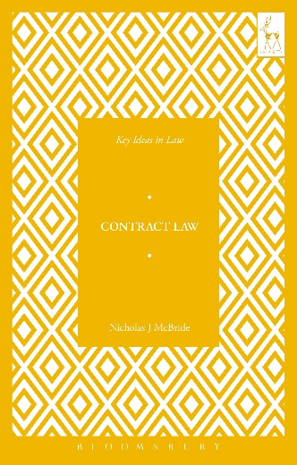
Key Ideas in Contract Law
Nicholas J McBride

This book introduces the reader to a number of ideas and issues that underlie the English law of contract—an area of law that is often regarded as forbiddingly dry and technical but which is here made easy to understand and full of interest.

Taking as its starting point the role contract law plays in helping markets to operate, the book explains how contract law regulates the commercial risks people take, while at the same time placing limits on what may be bought and sold, and ensuring that contractual powers are not unacceptably abused. A final chapter discusses how contract law can be used to make gifts of binding promises to other people. The book provides a rigorous and stimulating journey through the ideas underpinning contract law and is essential reading for anyone with an interest in the subject.

‘Clearly written and bursting with interesting and novel ideas, this lively book will be a great resource for anyone interested in Contract Law.’
Paul S Davies, Professor of Commercial Law, University College London

Nicholas J McBride is a Fellow of Pembroke College, Cambridge. He was formerly a Fellow of All Souls College, Oxford.

August 2017 | 9781509907212 | 144pp | Paperback | RSP: £9.99

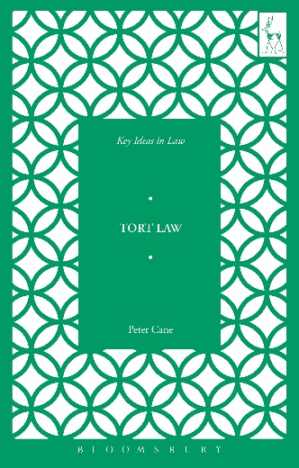
Key Ideas in Tort Law
Peter Cane

This book offers nine key ideas about tort law that will help the reader to understand its various social functions and evaluate its effectiveness in performing those functions. The book focuses, in particular, on how tort law can guide people’s behaviour, and the political and social environments within which it operates. It also provides the reader with a wealth of detail about the ideas and values that underlie tort ‘doctrine’—tort law’s rules and principles, and the way those rules and principles operate in practice. The book is an accessible introduction to tort law that will provide students, scholars and practitioners alike with a fresh and engaging view of the subject.

‘In this masterful and engaging survey, Peter Cane provides an array of illuminating perspectives on the law of torts, laying bare its nature, structure and functions, as well as its legal, social and political context.’
Andrew Robertson, Professor of Law, Melbourne Law School

Peter Cane is a Senior Research Fellow at Christ’s College, Cambridge. He was previously Distinguished Professor of Law at the Australian National University College of Law, and before that a Professor of Law at Corpus Christi College, Oxford.

August 2017 | 9781509909421 | 144pp | Paperback | RSP: £9.99

To order these books online visit www.hartpublishing.co.uk

